KINDER PASSION HE
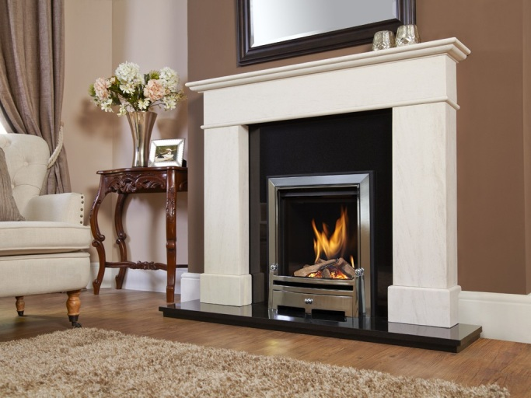
Kinder Passion HE Natural Gas Fire

The Passion HE is the first 16" x 22" gas fire to feature a truly authentic looking log effect fuel bed.
It features a stunning dancing flame effect, highlighted by a glossy black interior and framed by a large glass fronted viewing window.
- Radiant & Convected heat
- Full depth log fuel effect
- 3.95kW heat output
- 5.3kW heat input
- Net efficiency 82%
- Remote control operation only
- Available NG only
- Available finish in Ultimo Silver Trim & Bauhaus Silver Fret
- Chimney Flue Type: Brick Chimney; Pre-fabricated Flue†
- † These fires are suitable for most pre-fabricated flues dependent on the flue depth and diameter. Please refer to the installation instructions to ensure that this fire is compatible.
- Hearth or Wall Mounted. If wall mounted then a small plinth is required to support the fret.
- Sizes: Height (mm) 598 x Width (mm) 497 x Engine Depth (mm) 253

